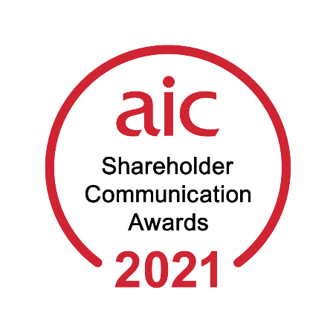

Entry form

If submitting an entry into more than one category, each entry must be emailed separately.

1. Entry details

Investment company/management group:

Contact person:

Email:

Tel:

2. Award category:

☐Best Marketing Campaign

☐Best PR Campaign

☐Best Report and Accounts

☐Best Social Media

☐Best Website

☐Best Factsheet

☐Best ESG Communication

Don’t forget Entries must be received by the AIC no later than 5pm on Friday 30 April 2021

3. To enter, please email:

☐An entry form

☐A supporting statement summarising the entry

☐Files containing supporting material

4. Submission details
Please email your entries to:

Elmley.delaCour@theaic.co.uk

Please note that we are unable to accept entries by post.
Entries by post will not be judged.

5. Winning entries
The winners will be announced by press release in June.

6. Rules

- The AIC office is closed. We are therefore unable to accept entries by post. Entries by post will not be judged.

- If submitting an entry into more than one category, each entry must be emailed separately.

- When emailing an entry, please attach separate files for the entry form, supporting statement and supporting material.

- All entries must be received by 5pm on Friday 30 April 2021.

- The winners will be announced by press release in June.

- The judges' decision is final.

- Please note: where relevant, we may use visual samples of winning entries.

Don’t forget Entries must be received by the AIC no later than 5pm on Friday 30 April

2021

